U18CO018

Shubham Shekhaliya

Assignment-2

Computer Graphics

1-> Explore different functions of graphics.h library.

2-> Write a program for the simulation of following functions: initGraphics, arc, bar, circle, line, rectangle, ellipse, outtext, outtextxy, cleardevice, closegraph, drawpoly, ellipse, fillpoly, fillArc, fillRect, setFont, getFont, getarccoords, getbkcolor, getColor, setColor, pause, waitForClick, settextstyle, setlinestyle, setfillstyle, pieslice.

3-> Write a program to design a car using pre-defined functions of graphics.h.

4-> Write a program to design a smiley face using graphics.h functions.

5-> Write a program to create circles inside various circles using graphics.h functions.

6-> Write a program to design traffic signal using graphics.h functions.

* initgraph :- initialize graph
* outtext :- to print
* outtextxy :- to print at any point
* settextstyle :- set style of the text
* rectangle :- draw rectangle
* line :- draw line
* arc :- draw arc
* bar :- draw bar
* circle :- draw circle
* ellipse :- draw ellipse
* cleardevice() :- clear the device
* drawpoly() :- draw poly
* fillellipse() :- fill ellipse
* fillpoly() :- fill poly
* pieslice() :- fill arc
* setlinestyle() :- to determine line style
* getbkcolor() :- get background colour
* setbkcolor() :- set background colour
* setfillstyle(): set fill style for the filling of the shape
* floodfill() :- fill the shape
* getcolor() :- get font colour
* setcolor() :- set font colour
* getmaxx() :- get maximum x coordinates
* getmaxy() :- get maximum y coordinates

# Code

#include<stdio.h>

#include<graphics.h>

int main() {

int gd = DETECT, gm;

initgraph(&gd,&gm,"");

char arrr[100];

sprintf(arrr, "Current background color = %d and line color = %d",getbkcolor(),getcolor());

settextstyle(5,0,1);

outtext(arrr);

//blank

rectangle(50,20,150,45);

line(50,60,150,60); //line

setcolor(GREEN);

circle(250,100,50); // cicle

setcolor(WHITE);

outtextxy(225,95,"Circle");

setlinestyle(2,0,1);

arc(375,100,0,135,50);//arc

setlinestyle(0,0,1);

arc(375,100,200,340,50);

bar(450, 40, 480, 150);//bar

ellipse(550,100,0,360,50,80);

outtextxy(525,90,"ellipse");

int ar[] = {50,70,150,100,50,130,90,100,50,70};

drawpoly(5,ar);

int p = getbkcolor();

//fill

int arr[] = {50,170,150,200,50,230,90,200,50,170};

fillpoly(5,arr);

pieslice(375,220,20,80,50);

setfillstyle(SOLID_FILL,5);

circle(250,200,40);

floodfill(250,200,WHITE);

getch();

cleardevice();

setbkcolor(GREEN);

outtext("Press any key for car");

getch();

setbkcolor(0);

cleardevice();

line(50,270,90,270);

arc(110,270,0,180,20);

line(130,270,220,270);

arc(240,270,0,180,20);

line(260,270,300,270);

arc(300,260,270,90,10);

line(300,250,240,230);

line(240,230,200,200);

line(200,200,110,200);

line(110,200,80,230);

line(80,230,50,240);

line(50,240,50,270);

line(165,205,165,230);

line(165,230,230,230);

line(230,230,195,205);

line(195,205,165,205);

line(160,205,160,230);

line(160,230,95,230);

line(95,230,120,205);

line(120,205,160,205);

circle(110,270,17);

circle(240,270,17);

line(0,290,639,290);

getch();

cleardevice();

outtext("Press any key for Smiley Face");

getch();

cleardevice();

setcolor(YELLOW);

circle(300, 200, 80);

setfillstyle(SOLID_FILL, YELLOW);

floodfill(300, 200, YELLOW);

setcolor(BLACK);

setfillstyle(SOLID_FILL, BLACK);

fillellipse(325, 175, 6, 15);

fillellipse(275, 175, 6, 15);

ellipse(300, 210, 205, 335, 60, 29);

ellipse(300, 210, 205, 335, 60, 30);

ellipse(300, 210, 205, 335, 60, 31);

getch();

setcolor(15);

cleardevice();

outtext("Press any key for circles");

getch();

cleardevice();

setcolor(BLUE);

circle(250,200,100);

setcolor(CYAN);

circle(250,200,80);

setcolor(YELLOW);

circle(250,200,60);

setcolor(RED);

circle(250,200,40);

setcolor(WHITE);

circle(250,200,20);

getch();

cleardevice();

outtext("Press any key for Traffic Signal");

getch();

cleardevice();

int midx = getmaxx()/2;

int midy = getmaxy()/2;

setcolor(WHITE);

rectangle(300,150,360,310);

circle(330, 180, 22);

setfillstyle(SOLID_FILL,RED);

floodfill(330, 180,WHITE);

delay(2000);

cleardevice();

setcolor(WHITE);

rectangle(300,150,360,310);

circle(330, 230, 22);

setfillstyle(SOLID_FILL,YELLOW);

floodfill(330, 230,WHITE);

delay(2000);

cleardevice();

setcolor(WHITE);

rectangle(300,150,360,310);

circle(330, 280, 22);

setfillstyle(SOLID_FILL,GREEN);

floodfill(330, 280,WHITE);

getch();

closegraph();

return 0;

}

* Use of various function

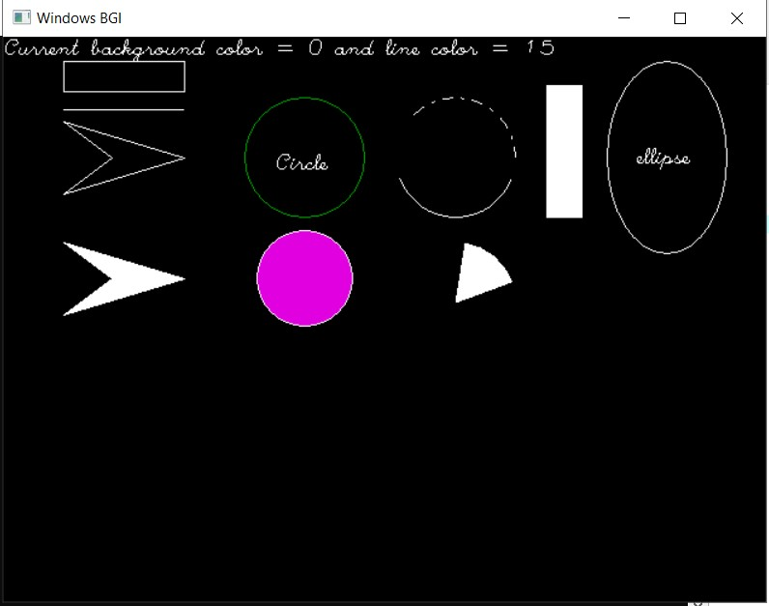

* Draw Car

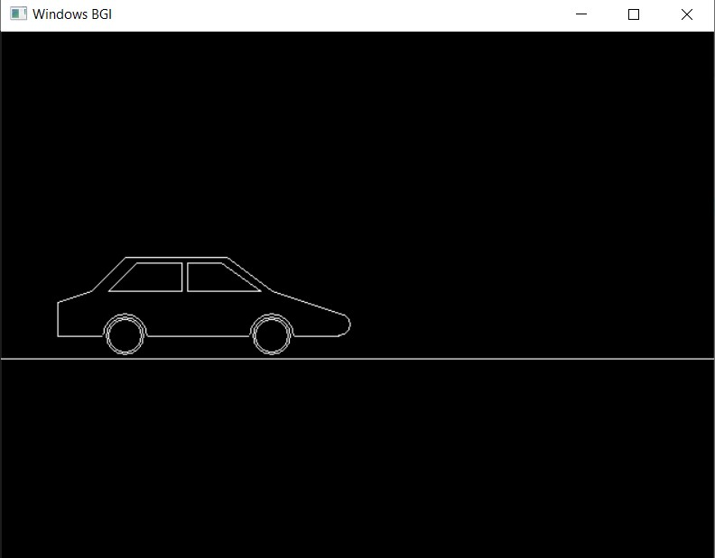

* Draw Smiley Face

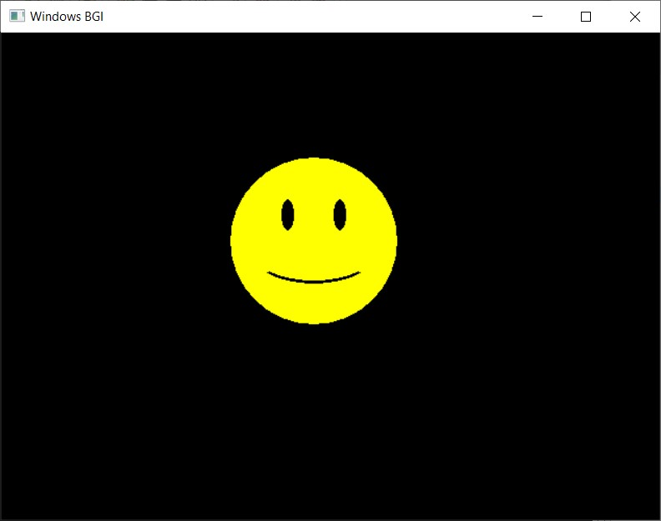

* Draw Circles

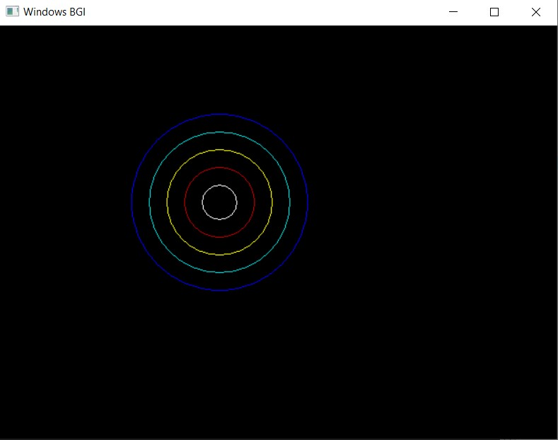

* Draw Traffic Signal

